Name: ___________________________________ Date: _____________________ Per:__________

Plants: Bozeman video

Eukaryotes have a N_______________________ and O_________________________

G_________________ A________________ is the first plant on the chart.

**Four Groups of plants:** Share a common ______________________________

M_____________ (Bryophytes)

F_____________

G________________________

A________________________

------------------------------------------------------------------------------------------------------------------------------------

**Land Plant Characteristics:**

E____________________________

A____________________________ = _____________________________________________________

C___________________ W_____________________ with ____________________________________

T____________________________ = _______________________ __________________________

Alternation of G_____________________________

Embryophytes = have P________________________ E_______________________

--------------------------------------------------------------------------------------------------------------------------------------

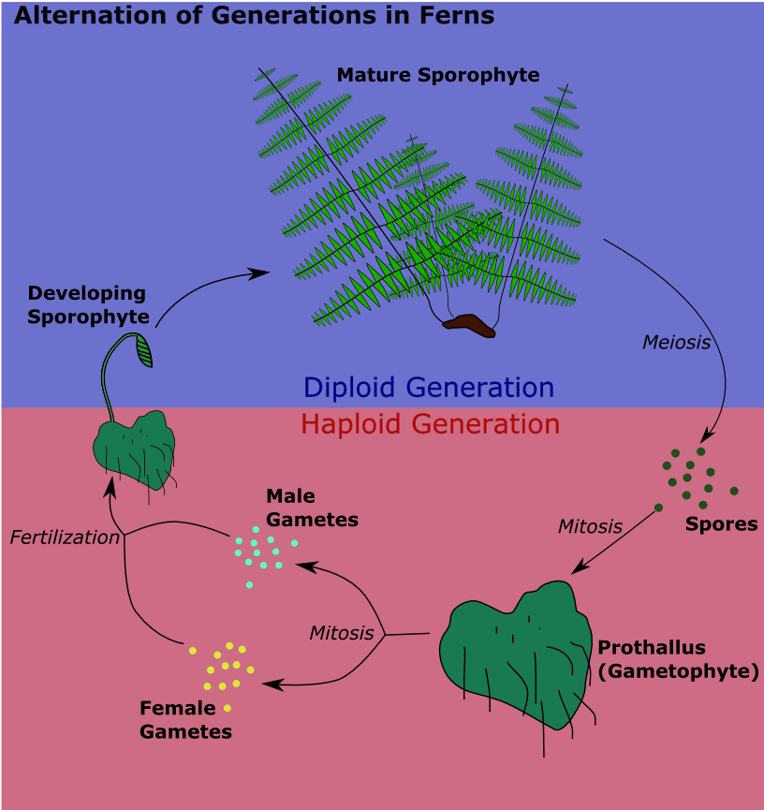Alternation of Generation = Two L__________ C______________

1. Sporophyte (ex. Humans, conifers)
2. Gametophyte= ___________ set of chromosomes

(ex. Mosses)

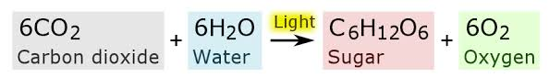Photosynthesis:

What do they do with the energy from photosynthesis? S_______________________, build

S_____________________________, release the energy as A _ _

Four Important Steps for Plants:

1. From WATER to ______________________ ex) Bryophytes ( )
2. To V_______________________ T__________________

ex) Ferns that have X_______________ and P____________ to move _______________________

1. S_______________ evolved next to protect _______________________

Ex) Gymnosperms = naked seed, ex) C_____________________

1. Angiosperms = evolution of the F_____________________

The flower coevolved with I_____________________, giving them the ability to R________________

Flower – insects get nectar, pick up pollen, and transport pollen to another location.

---------------------------------------------------------------------------------------------------------------------------------------

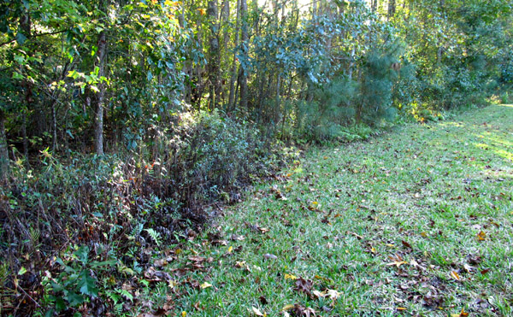An **ecotone** is a transition area between two [biomes](http://en.wikipedia.org/wiki/Biome). It is where two communities meet and integrate. It may be narrow or wide, and it may be local (the zone between a field and forest) or regional (the transition between forest and grassland [ecosystems](http://en.wikipedia.org/wiki/Ecosystem)). An ecotone may appear on the ground as a gradual blending of the two communities across a broad area, or it may manifest itself as a sharp boundary line. The word ecotone was coined from a combination of *eco*(logy) plus *-tone*, from the [Greek](http://en.wikipedia.org/wiki/Greek_language) *tonos* or tension – in other words, a place where ecologies are in tension.

**Limiting factor -** In biological or ecological terms, a limiting factor causes a population to decrease in size. A few limiting factors are food, shelter, water, space.